Lab Exercise 4 – Harmonization & Unification (Identity Resolution)

This lab helps learners understand how Salesforce Data Cloud unifies fragmented customer data across multiple sources into a single “golden profile.”
Objective
By the end of this lab, learners will be able to:
- Create and configure an Identity Resolution Ruleset in Salesforce Data Cloud.
- Apply Exact, Normalized, and Fuzzy match rules.
- Configure Reconciliation Rules to determine which data wins during merging.
- Run and preview ruleset results.
- Analyze the Resolution Summary and verify unified profiles using Profile Explorer.

Hands-on: Create and Test an Identity Resolution Ruleset

Step 1: Navigate to the Identity Resolution Workspace
- Log in to your Salesforce Data Cloud Developer Edition.
- From the App Launcher (grid icon), search for and open the Data Cloud app.
- In the left-hand navigation pane, select Identity Resolution.
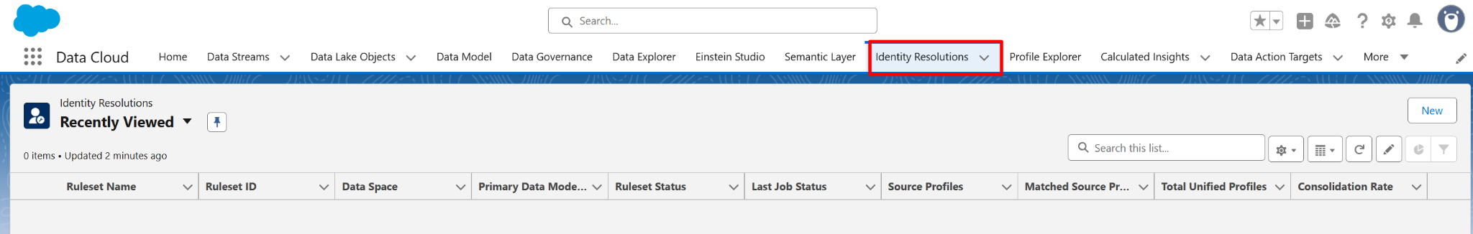

- You’ll land on the Rulesets page — this lists any existing or sample rulesets.

Step 2: Create a New Ruleset
- Click the New Ruleset button (top-right corner).
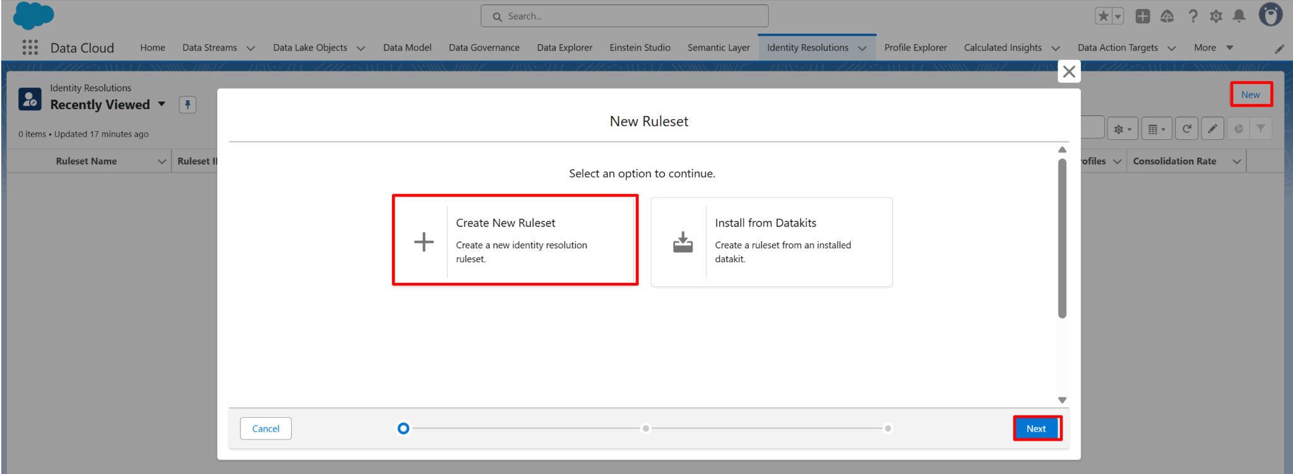
- In the Ruleset Properties window:
  - Label: Customer Unification Ruleset
  - API Name: auto-fills
  - Data Model Object (DMO): Select Individual (or your Customer Profile DMO).
  - Description: Unify customer records from CRM and Web Engagement based on name, email, and phone.
- Click Save & Next.

Step 3: Define Match Rules
You’ll now configure how the system identifies matching records across sources.

3.1 Add Exact Match Rule
- Click Add Rule.
- Set:
  - Rule Name: Exact Email Match
  - Match Type: Exact
  - Fields: Email
  - Active: Checked
- Click Save Rule.
💡 Use exact match for unique, structured fields like Email or Customer ID.

3.2 Add Normalized Match Rule
- Click Add Rule again.
- Set:
  - Rule Name: Normalized Phone Match
  - Match Type: Normalized
  - Fields: MobilePhone
  - Active: Checked
- Click Save Rule.
💡 Normalization removes special characters, spaces, and formatting differences (e.g., +91-999 vs. 0999).

3.3 Add Fuzzy Match Rule
- Click Add Rule again.
- Set:
  - Rule Name: Fuzzy Name Match
  - Match Type: Fuzzy
  - Fields: FirstName, LastName
  - Active: Checked
- Click Save Rule.
Fuzzy matching uses phonetic similarity — it can catch “Jon” vs “John.”

Step 4: Configure Reconciliation Rules
After defining how to match, you must define how Salesforce decides which field values to keep in the unified profile.
- Click the Reconciliation Rules tab (next to Match Rules).
- For each field group (e.g., Email, Phone, Address, Name), choose:
  - Rule Type:
    - Most Recent → Keeps data from the latest updated record.
    - Most Frequent → Uses the value that appears most often.
    - Source Priority → Prefers a specific data source.
- Example configuration:
Field | Rule Type | Notes
Email | Most Frequent | Avoids one-off email typos
Phone | Most Recent | Keeps freshest phone number
Address | Source Priority | Prefer CRM over Engagement
- Click Save.

Step 5: Run the Ruleset
- From the top-right, click Run.
- In the pop-up:
  - Choose Preview Mode if you want to see results without committing.
  - Or select Full Run to actually consolidate data.
- Click Run Ruleset.

Step 6: View the Resolution Summary
Once the run completes (can take 1–3 minutes for sample data):
- Open your Ruleset Details Page → select the Resolution Summary tab.
- Review key metrics:
  - Records Processed: Total profiles checked.
  - Matched Pairs: Number of detected duplicates.
  - Unified Profiles Created: How many golden profiles were built.
  - Average Match Confidence: (Higher % = better rule accuracy)
- Click View Details to expand results and see which rule contributed most to matching (Exact / Fuzzy / Normalized).
If match rates seem low, experiment by adjusting field combinations or match types.

Step 7: Iterate and Improve
- Click Clone Ruleset (from top-right) to make a copy for testing.
- Add another field — for example, City or PostalCode — to improve confidence.
- Run again and compare Resolution Summary results.
- Note the difference in Match Rate and Unified Profiles.

Step 8: Validate Unified Profiles
- In the Data Cloud navigation, click Profile Explorer.
- Search for a customer by Email or Full Name.
- Open one of the unified profiles.
- In the Identity Resolution panel, you’ll see:
  - Linked source records (CRM + Engagement).
  - Which fields were reconciled (highlighted with “winning” data).
  - Data provenance (source object name).
- Expand the record to view Engagement Events, Purchases, or other linked datasets.
You’ve now validated your unified “Golden Record” profile successfully!

